भारत मौसम विज्ञान विभाग |  | India Meteorological Department
Wednesday 06th May 2026 (16th Vaisakha 1948 Saka)
Summary of observations recorded at 0830 hours IST: The Western Disturbance as a cyclonic circulation over Kashmir & neighbourhood seen as a trough in westerlies between 3.1 & 7.6 km above m. s. l. ran roughly along Long. 80°E to the north of Lat. 25°N. The upper air cyclonic circulation over southwest Rajasthan extended upto 1.5 km above m. s. l. persisted. The upper air cyclonic circulation over East Uttar Pradesh lay over northeast Uttar Pradesh & neighbourhood at 0.9 km above m. s. l. An upper air cyclonic circulation lay over central Assam & neighbourhood at 0.9 km above m. s. l. An upper air cyclonic circulation lay over north Telangana & neighbourhood at 1.5 km above m. s. l. at 0530 hrs IST of today morning. It then persisted over the same region. An upper air cyclonic circulation lay over Gulf of Mannar & neighbourhood at 1.5 km above m. s. l. The north-south trough/Wind discontinuity from cyclonic circulation over central parts of south Madhya Pradesh to Gulf of Mannar ran from North Interior Karnataka to Gulf of Mannar across Rayalaseema and Tamil Nadu at 0.9 km above m. s. l. A fresh Western Disturbance is likely to affect Western Himalayan Region from 10th May, 2026. The trough from the cyclonic circulation over central parts of south Madhya Pradesh to Bihar became less marked. The upper air cyclonic circulation over central parts of south Madhya Pradesh became less marked at 0530 hrs IST of today. The upper air cyclonic circulation over Haryana & neighbourhood became less marked at 0530 hrs IST of today. The north-south trough roughly along Long. 89°E to the north of Lat. 21°N at 3.1 km above mean sea level has moved away at 0530 hrs IST of today.
Maximum Temperature Departures (as on 05-05-2026): above normal (1.6°C to 3.0°C) at most places over Konkan & Goa; at few places over East Madhya Pradesh; at isolated places over Himachal Pradesh and Tamil Nadu, Puducherry & Karaikal. near normal (-1.5°C to 1.5°C) at many places over South Interior Karnataka and Kerala & Mahe; at most places over West Rajasthan, Coastal Andhra Pradesh & Yanam, Rayalaseema and North Interior Karnataka; at few places over East Uttar Pradesh, West Uttar Pradesh and West Madhya Pradesh. The highest maximum temperature of 43.5°C was reported at Wardha (Maharashtra).
Thunderstorm accompanied with Squally/Gusty winds with speed reaching 50-90 kmph prevailed at isolated places over Vidarbha, Uttar Pradesh, Andaman & Nicobar Islands, Odisha, Jharkhand, Bihar, Gujarat Region, Tamil Nadu, Puducherry & Karaikal, with speed reaching 30-50 kmph prevailed at isolated places over Madhya Pradesh, Uttarakhand, Himachal Pradesh, Saurashtra & Kutch.
Hailstorm reported over Uttar Pradesh, East Madhya Pradesh, Vidarbha, Maharashtra and Delhi.
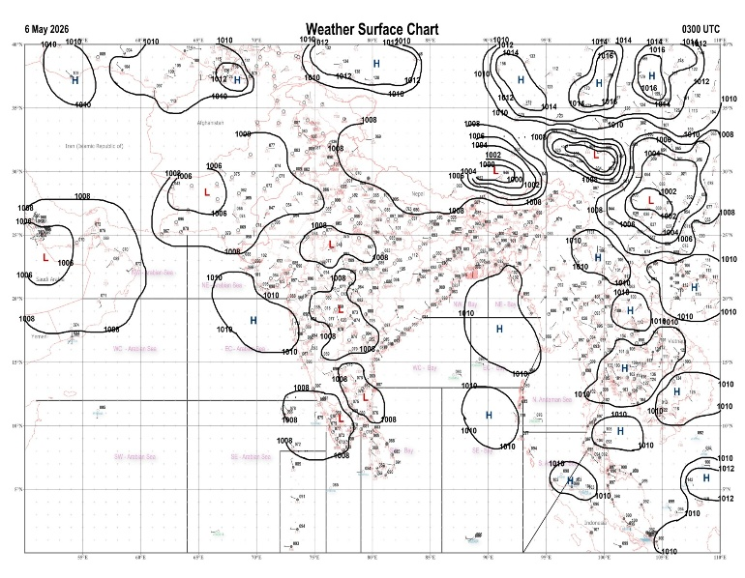 | 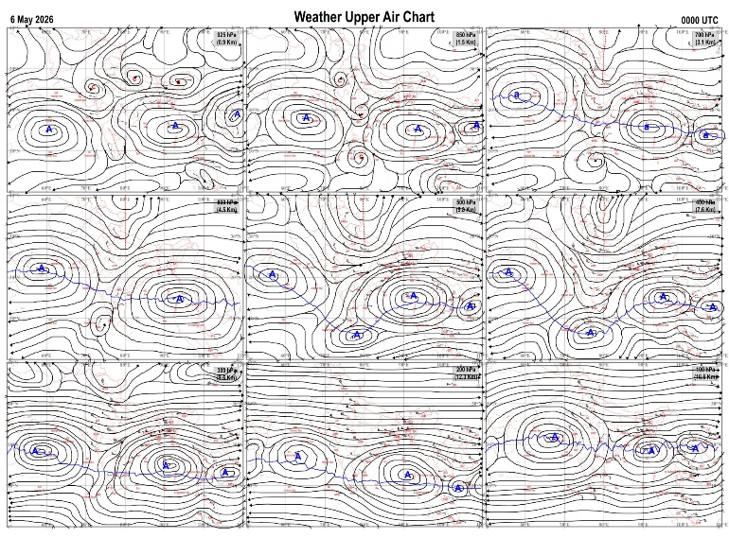
Fig.1. Analysed surface chart based on 03z observation | Fig.2. Analysed upper air chart based on 00z observation
V.K.Shripad
Scientific Officer ‘I’
CR & S Office, Pune  Issued at 1245 hrs. IST |  | Weather Forecasting Division  CR&S, Pune

Indian regions | Realised rainfall (chief amount in cm during past 24 hrs):
East | a few places: Arunachal Pradesh, Nagaland-Manipur-Mizoram-Tripura, Sub-Himalayan West Bengal & Sikkim, Odisha+ and Bihar  isolated places: Assam & Meghalaya, Gangetic West Bengal◆ and Jharkhand  Gunupur 9.6, Lanjigarh 7.1, Siliguri PTO 5.4, Moranhat & Saraigarh bhaptiyahi 4.3 each, Suryasen mahavidyalaya & Basua 3.7 each, Simdega 3.4, Jharsuguda 3.3, Tuting 2.8, Supaul 2.6, Margherita, Kvk south & Bagdogra IAF 2.3 each, Daporizo AWS & Jaganathpur bau kvk AWS 2.1 each, Mangkolemba 1.8, Pasighat AP 1.6, Lengpui 0.9, Sagar island PTO 0.1.
North | a few places: Uttarakhand and Himachal Pradesh  isolated places: Uttar Pradesh, Haryana, Punjab, Jammu-Kashmir and Ladakh and Rajasthan  Shikohabad 4.9, Khekda 4.4, Ranikhet (g) 3.1, Churk 2.9, Sumerpur SR 2.6, Bapouli 2.5, Chakrata 2.2, Bara 2.1, Bahadurgarh 1.9, Simla 1.8, Gogunda SR & Kotda SR 1.6 each, Uttar kashi 1.4, Nahan 1.3, Muzaffarnagar & Erinpura / Jawai dam 1.2 each, Palam & Udaipur / D-aero 1.0 each, Bali 0.9, Prayagraj PBO 0.8, Kahu 0.7, Shahpur kandi 0.5, Madhopur 0.4, Chatha agro AWS 0.3, Batote & Pahalgam AWS 0.1 each.
Central | isolated places: Madhya Pradesh, Vidarbha+ and Chhattisgarh  Amgaon 6.9, Salekasa 5.0, Amarwara & Kutaru 4.5 each, Labhandih 4.2, Rampur 3.3, Raipur 2.6, Rewa-aws 2.2, Ranapur 1.0, Lahar 0.9, Pachmarhi & Bramhapuri 0.1 each.
Peninsula | a few places: Kerala+++  isolated places: Gujarat State, Marathwada◆, coastal Andhra Pradesh, Telangana, Tamil Nadu+, coastal Karnataka and interior Karnataka  dry weather: Konkan & Goa, Madhya Maharashtra and Rayalaseema  Urumi AWS 17.0, Karapuzha AWS 7.1, Vadipatti 6.9, Konanur 6.0, Usilampatti 5.5, Sompeta & Madurai south 4.5 each, Amalapuram 4.3, Puttur HMS 3.6, Jaipur 3.5, Govindaraopet 3.2, Somwarpet 2.9, Karipur ap. 1.6, Hakimpet IAF & Bantwal 1.5 each, Jhalod 1.4, Belagavi AP 0.9, Kalingapatnam 0.7, Dahod 0.6, Dhari 0.4, Bengaluru city 0.3, Jamkandorna & Partur 0.2 each, Mangaluru AP 0.1.
Islands | many places: Andaman & Nicobar+  dry weather: Lakshadweep  Long island 7.0, Hut bay 3.0, Port blair 0.7.
Table-2 Forecast / warnings (distribution of rain / thundershowers) for 7 days (valid from time of origin upto 0830 hrsIST of next day)
Sr N. |  | Sub-division Name | Day 1 | Day 2 | Day 3 | Day 4 | Day 5 | Day 6 | Day 7 | Sr. No. | Sub-division Name | Day 1 | Day 2 | Day 3 | Day 4 | Day 5 | Day 6 | Day 7
 |  |  | 06 May | 07 May | 08 May | 09 May | 10 May | 11 May | 12 May |  |  | 06 May | 07 May | 08 May | 09 May | 10 May | 11 May | 12 May
 | 1 | Andaman Nicobar Islands | F  | F  | F  | F  | F | F | F | 19 | west Madhya Pradesh | I  | I  | D | D | D | D | D
 | 2 | Arunachal Pradesh | F +  | F  | S | S | S | S | S | 20 | east Madhya Pradesh | I  | I  | I | D | D | D | D
 | 3 | Assam-Meghalaya | F +  | S  | S  | S  | S  | S | S | 21 | Gujarat region | D | D | D | D + | D + | D + | D +
 | 4 | Nagaland-Manipur-Mizoram-Tripura | S  | S  | I  | I | I | I | I | 22 | Saurashtra and Kutch | I | D | D | D + | D + | D+ | D +
 | 5 | Sub Him West Bengal/Sikkim | W +  | F  | S  | S  | I | I | S | 23 | Konkan and Goa | D  + | I  + | I  + | D + | D | D | D
 | 6 | Gangetic West Bengal | S  | S  | S  | F  | S | I | I | 24 | Madhya Maharashtra | I  | I  | I  | D | D | D | D
 | 7 | Odisha | S  | I  | I  | I  | I  | I  | I  | 25 | Marathwada | I  | I  | I  | I | D | D | D
 | 8 | Jharkhand | I  | I  | I  | S  | S | I | S | 26 | Vidarbha | I  | D | D | D | D | D | D
 | 9 | Bihar | I  | I  | I  | I  | I | I | D | 27 | Chhattisgarh | I  | I  | I  | I  | I  | I | I
 | 10 | east Uttar Pradesh | I | I  | D | D | D | D | I | 28 | Coastal Andhra Pradesh and Yanam | S  | S  | S  | I  | I  | I | I
 | 11 | west Uttar Pradesh | I | I  | D | D | D | I | I | 29 | Telangana | I  | I  | I | I | I | D | D
 | 12 | Uttarakhand | S  | S  | I  | I | I | S | S | 30 | Rayalaseema | I  | S  | S  | I  | I  | I | I
 | 13 | Haryana,Chandigarh and Delhi | I  | I  | D | D | I | I | I | 31 | Tamil Nadu, Puducherry and Karaikal | I +  | I +  | S+ | S + | S+ | S + | S +
 | 14 | Punjab | I  | I  | D | D | I | I | I | 32 | Coastal Karnataka | I  | I  | S  | I  | I  | I | I
 | 15 | Himachal Pradesh | I | I | D | D | D | S | S | 33 | North interior Karnataka | I  | I  | I  | I  | I  | I | I
 | 16 | Jammu-Kashmir and Ladakh | I | I | D | D | I | S | S | 34 | South interior Karnataka | I  | I +  | I + | I  | I  | I | I
 | 17 | west Rajasthan | I  | D | D | D + | D + | D + | D | 35 | Kerala and Mahe | F+ | F +  | W+ | W+ | W+ | W + | W +
 | 18 | east Rajasthan | I  | I  | I | I | D | D | D | 36 | Lakshadweep | S | S | F | F  | F  | F | F
Legends: D = Dry I =isolated S = Scattered F = Fairly widespread W = Widespread #= heavy to very heavy rain at a few places with extremely heavy rain at isolated places+++= heavy rain at a few places with very heavy rain at isoIated places++= heavy to very heavy rainfall @=isolated exceptionally heavy rainfall+ = heavy rain ●/*= rain or snow ♦ = very light rain ≡=fog = thunderstorm with lightning =Squall / Gusty / gale / strong wind -=cold wave/cold day + = heat wave/warm night/hot and humid weather =Duststorm =ground frost = Hail.

Fig. 4: Districtwise warnings for five days for Maharashtra State
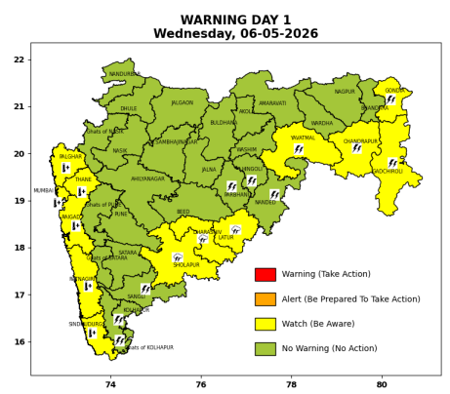 | 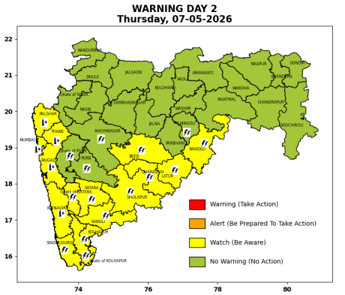 | 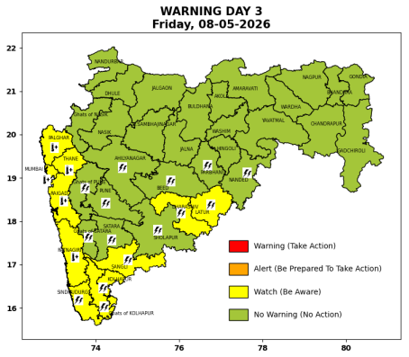 | 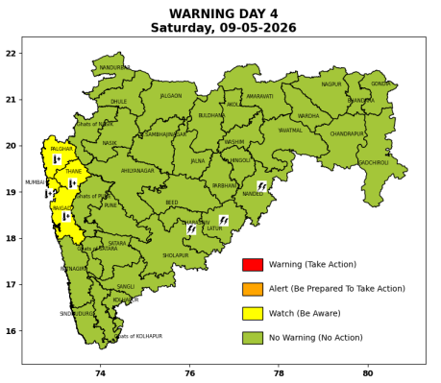 | 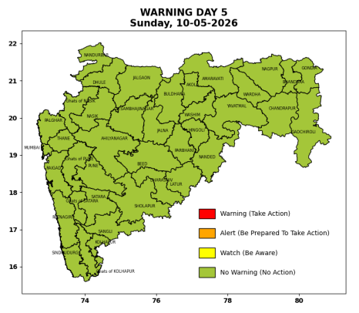

Pune, Lohegaon and Pashan observations at 0830 hrs. IST of Today
 | Temperature (°C) |  |  |  |  | Humidity (%) |  |  |  | Rainfall (mm)
 | Max.  past  24 hrs | Dep.  from  normal | Min.  past  24 hrs. | Dep.  from  normal | Dry  Bulb | At 0830 hrs. IST | Dep.  From  normal | At 1730  hrs. IST of y’day | Dep.  from  normal | Past  24 hrs. | Since  1st March | Dep.  from  normal
PNE | 37.2 | -1.3 | 22.1 | -0.5 | 26.0 | 66 | 10 | 34 | 6 | 0.0 | 92.8 | 74.3
PSN | - | - | - | - | - | - | - | - | - | - | - | -
LHG | 40.1 | 2.1 | 24.5 | 3.5 | 28.8 | 52 | -3 | 23 | -4 | 0.0 | 91.4 | 68.2

 |  |  |  |  |  |  | Local (Pune and neighbourhood) forecast
Max./Min. Temperature (°C) |  |  |  |  |  |  |  |  | Weather
Date | Pune | Pashan | Lohegaon | Chinchwad | Lavale | Magarpatta | NDA | Koregoan park
06/05/26 | 39 / 22.1* | 38 / - | 41 / 24.5* | 38 / 23.5* | 38 / 19.7* | 41 / - | 38 / 19.9* | 41 / - | Mainly clear sky.
07/05/26 | 38 / 22 | 37 / 22 | 40 / 25 | 37 / 24 | 37 / 20 | 40 / 25 | 37 / 22 | 40 / 25 | Mainly clear sky
08/05/26 | 39 / 23 | 38 / 23 | 41 / 26 | 38 / 25 | 38 / 21 | 41 / 26 | 38 / 23 | 41 / 26 | Mainly clear sky
09/05/26 | 39 / 23 | 38 / 23 | 41 / 26 | 38 / 25 | 38 / 21 | 41 / 26 | 38 / 23 | 41 / 26 | Mainly clear sky
10/05/26 | 39 / 22 | 38 / 22 | 41 / 25 | 38 / 24 | 38 / 20 | 41 / 25 | 38 / 22 | 41 / 25 | Mainly clear sky
11/05/26 | 40 / 22 | 39 / 22 | 41 / 25 | 39 / 24 | 39 / 20 | 41 / 25 | 39 / 22 | 41 / 25 | Mainly clear sky
12/05/26 | 40 / 22 | 39 / 22 | 41 / 25 | 39 / 24 | 39 / 20 | 41 / 25 | 39 / 22 | 41 / 25 | Mainly clear sky
Rainfall Distribution |  |  |  |  | Rainfall Categories | Rainfall (mm) | Cloud condition |  | Rainfall Intensity | Range
Widespread (W) | 76-100% |  |  |  | Very Light rain | Trace to 2.4 mm | Mainly clear sky | 1-2 oktas | Light Spell | 1 cm/hr
 |  |  |  |  | Light rain | 2.5 to 15.5 mm | Partly cloudy sky | 3-4 oktas | Moderate Spell | 1-2 cm/hr
Fairly Widespread (FW) | 51 – 75% |  |  |  | Moderate rain | 15.6 to 64.4 mm | Generally cloudy sky | 5-7 oktas | Intense Spell | 2-3 cm/hr
Scattered (S) | 26 – 50% |  |  |  | Heavy rain | 64.5 to 115.5 mm | Overcast | 8 oktas | Very Intense Spell | 3-5 cm/hr
Isolated (I) | 1 – 25% |  |  |  | Very heavy rain | 115.6 to 204.4 mm |  |  | Extremely Intense Spell | 5-10 cm/hr
Dry (D) | No Rain |  |  |  | Extremely heavy rain | ≥ 204.5 mm |  |  | Cloudburst | > 10 cm/hr
Probability Terms in %: |  |  |  |  | Heavy snow | 6.5 to 11.5 cms water equivalent of rain
unlikely | < 25 |  |  |  | Very heavy snow | 11.6 to 20.4 cms water equivalent of rain
likely | between 25 50
very likely | between 51 75
most likely | >75
* = realized temperatu
Mumbai (Colaba) |  |  |  | Nagpur (AP)
Date 2026 | T max °C | T min °C | Weather | T max °C | T min °C | Weather
06/05/26 | 35 | 27 | Mainly clear sky. | 41 | 24 | Partly cloudy sky.
07/05/26 | 35 | 28 | Mainly clear sky. | 43 | 25 | Partly cloudy sky.
08/05/26 | 35 | 28 | Mainly clear sky. | 44 | 26 | Partly cloudy sky.
09/05/26 | 35 | 29 | Mainly clear sky. | 44 | 26 | Mainly clear sky.
10/05/26 | 34 | 29 | Mainly clear sky. | 43 | 26 | Mainly clear sky.
11/05/26 | 34 | 29 | Mainly clear sky. | 44 | 26 | Mainly clear sky.
12/05/26 | 34 | 29 | Mainly clear sky. | 44 | 26 | Mainly clear sky.

